
ENGREG HIGH SCHOOL
24, Bankole Street, Pedro, Shomolu, Lagos
SS 2 DATA PROCESSING SCHEME OF WORK
2024/2025 SESSION

FIRST TERM
WEEKS | TOPIC | SUB-TOPIC
ONE | Data Models | Definition, Parts and types of Data Modelling.
TWO | Data Modelling | Definition, approaches, Library Database, Significance of data model.
THREE | Normal Form I | Data Normalization, Definition of Normal Form and its various types.
FOUR | Normal Form II | Problems facing the first normal form, Example of tables in First, Second and Third Normal form.
FIVE | Entity Relationship Model I | Definition, Entities, Attributes and its types
SIX | Entity Relationship Model II | Relationship between entities.
SEVEN | Relational Model I | Definition, Concepts,
EIGHT | Relational Model II | Relational Model Keys, Integrity Constraints over Relations.
NINE | Relational Model III | Creating a database, Querying a database,
TEN | Revision
ELEVEN | Examination

ENGREG HIGH SCHOOL
24, Bankole Street, Pedro, Shomolu, Lagos
WEEK: 1 FIRST TERM SESSION: 2024/2025
SUBJECT: DATA PROCESSING |  | TOPIC: DATA MODELS
CLASS: SS 2 | DATE: 9th – 13th September, 2024 | REFERENCE BOOKS: A Textbook for Data Processing SS 2 by Adedapo F. O. et al Pages 1-7  Data Processing Textbook for SS 2 by Aboyede Jegede 1 - 8
LEARNING PURPOSE: To provide learners with a foundational understanding of data modelling, its types and approaches. |  |  |  | LESSON PERIOD: 1  DURATION: 40 MINS
LEARNING OBJECTIVE: By the end of the lesson, students will be able to:  - Define Data Model.  - Define Data Modelling.  - List the types of data modelling. |  |  |  | KEYWORDS: Data Model, Data Modelling, Hierarchical, Approaches.
PREVIOUS LEARNING: The students are familiar with how database management system. |  | INSTRUCTIONAL MATERIALS:  Interactive board, computer system, Internet
LEARNING ACTIVITIES IN STEPS:  Step 1: The teacher marks assignment and makes correction.  Step 2: The teacher asks questions on previous knowledge  Step 3: The teacher modifies students’ response and introduces the new topic  Step 4: Students would be taken through the derailed explanation of the lesson content  Step 5: Students ask questions on the content of the lesson  Step 6: Students would be evaluated based on behavioural objectives  Step 7: Students Assignments are given and notes and marked |  |  | LEARNING TIME FOR EACH STEP:  Step 1: 3mins  Step 2: 2mins  Step 3: 3mins  Step 4: 20mins  Step 5: 2mins  Step 6: 7mins  Step 7: 3mins
LEARNING SKILLS:  Critical thinking, creative thinking, communicating and leadership development |  | ACTIVITY  Define data model and modelling.
EVALUATIVE QUESTIONS:  - Define Data Model.  - Define Data Modelling.  - List 5 types of data modelling. |  | ASSIGNMENT  Explain any two types of data models with the help of a diagram.

DATA MODEL
A data model focuses on representing data as the user in the real world perceives it, rather than how a database might interpret it. It remains independent of specific hardware or software constraints.
Data modeling is the process of creating a visual blueprint that represents a system's data elements and their relationships. It organizes and structures data to support the design, management, and use of databases, ensuring efficient data storage and retrieval.
Types of Data Models
- Flat- File Model: The flat model is the simplest and earliest data model, consisting of a single table with rows and columns. Data is stored in a flat file, which could be a plain text file or a binary file.
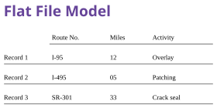
- Hierarchical Data Model: The hierarchical data model is optimized for hierarchical structures, such as an organizational chart. This model works well for representing one-to-many relationships, where data is structured in a tree-like format.
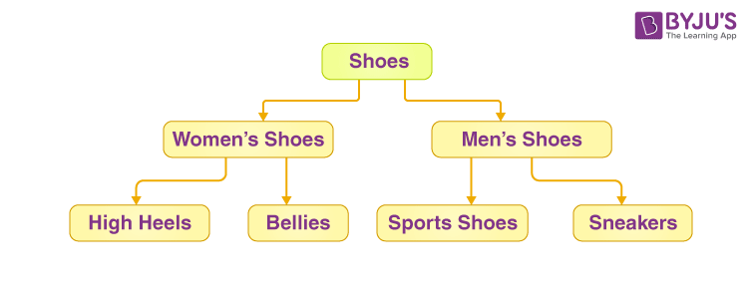
- Network Data Model: The network data model offers a more flexible way to represent objects and their relationships, using nodes and arcs in a graph. Unlike the hierarchical model, the network model allows for more complex many-to-many relationships.
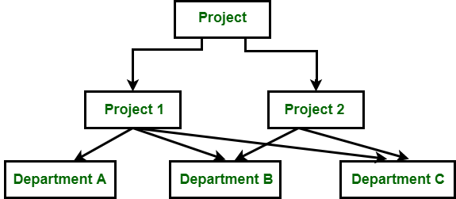

ENGREG HIGH SCHOOL
24, Bankole Street, Pedro, Shomolu, Lagos
WEEK: 1 FIRST TERM SESSION: 2024/2025
SUBJECT: DATA PROCESSING |  | TOPIC: DATA MODELS
CLASS: SS 2 | DATE: 9th – 13th September, 2024 | REFERENCE BOOKS: A Textbook for Data Processing SS 2 by Adedapo F. O. et al Pages 1-7  Data Processing Textbook for SS 2 by Aboyede Jegede 1 - 8
LEARNING PURPOSE: To provide learners with a foundational understanding of data modelling, its types and approaches. |  |  |  | LESSON PERIOD: 2  DURATION: 40 MINS
LEARNING OBJECTIVE: By the end of the lesson, students will be able to:  - Explain any two types of data models.  - List the three approaches to data modelling.  - Explain the three different approaches to data modelling. |  |  |  | KEYWORDS: Data Model, Data Modelling, Hierarchical, Approaches.
PREVIOUS LEARNING: The students are familiar with how database management system. |  | INSTRUCTIONAL MATERIALS:  Interactive board, computer system, Internet
LEARNING ACTIVITIES IN STEPS:  Step 1: The teacher marks assignment and makes correction.  Step 2: The teacher asks questions on previous knowledge  Step 3: The teacher modifies students’ response and introduces the new topic  Step 4: Students would be taken through the derailed explanation of the lesson content  Step 5: Students ask questions on the content of the lesson  Step 6: Students would be evaluated based on behavioural objectives  Step 7: Students Assignments are given and notes and marked |  |  | LEARNING TIME FOR EACH STEP:  Step 1: 3mins  Step 2: 2mins  Step 3: 3mins  Step 4: 20mins  Step 5: 2mins  Step 6: 7mins  Step 7: 3mins
LEARNING SKILLS:  Critical thinking, creative thinking, communicating and leadership development |  | ACTIVITY  Illustrate the Relational type of data model.
EVALUATIVE QUESTIONS:  - Explain two types of data models.  - List three approaches to data modelling.  - Explain any two approaches to data modelling. |  | ASSIGNMENT  Explain the physical approach of data model.

TYPES OF DATA MODEL
- Relational Data Model: The relational data model, organizes data into tables, each representing a single logical entity. Relationships between tables are established through columns containing unique identifiers. This model is highly efficient for managing large datasets.
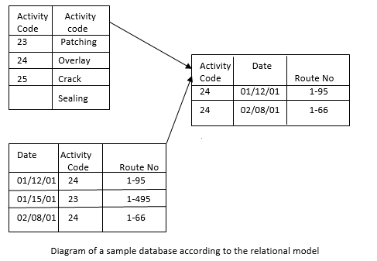
- Entity-Relationship Data Model: The entity-relationship (ER) model is widely used in enterprise applications. It emphasizes minimal redundancy and clearly defined relationships between entities. The key components of the ER model are:
- Entities: Objects, events, people, or concepts represented in tables.
- Attributes: Unique characteristics of each entity, stored as data in columns.
- Relationships: Logical links between entities, representing business rules or constraints.
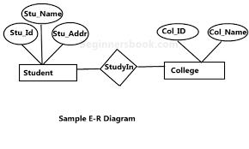
Approaches to Data Modeling
- Conceptual Data Model: The conceptual data model provides a high-level overview of the system's key entities and their relationships. This model is independent of technology and application, serving as a foundation for further development.
- Logical Data Model: The logical data model adds more detail to the conceptual model by defining specific entities, attributes, and relationships. It clarifies the data structure, resolves many-to-many relationships, and defines keys, all while remaining independent of specific database technology.
- Physical Data Model: The physical data model translates the logical model into technical specifications for a specific database management system (DBMS). It defines data types, constraints, indexes, and storage details, ensuring that the database is optimized for performance and storage.

